Chapter 10
Capital Markets and the Pricing of Risk
10-1. The figure below shows the one-year return distribution for RCS stock. Calculate
a. The expected return.
b. The standard deviation of the return.
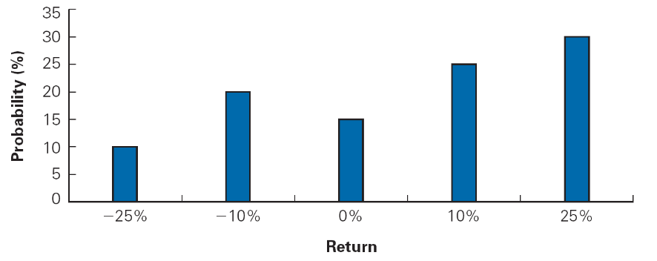

a.
b. 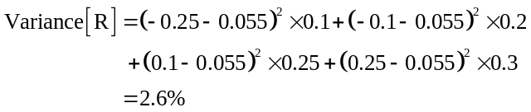
10-2. The following table shows the one-year return distribution of Startup, Inc. Calculate
a. The expected return.
b. The standard deviation of the return.
a.
b. 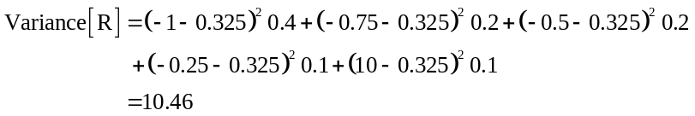
10-3. Characterize the difference between the two stocks in Problems 1 and 2. What trade-offs would you face in choosing one to hold?
Startup has a higher expected return, but is riskier. It is impossible to say which stock I would prefer. It depends on risk performances and what other stocks I’m holding.
10-4. You bought a stock one year ago for $50 per share and sold it today for $55 per share. It paid a $1 per share dividend today.
a. What was your realized return?
b. How much of the return came from dividend yield and how much came from capital gain?
Compute the realized return and dividend yield on this equity investment.
a. 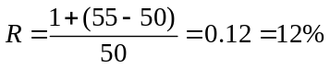
b. 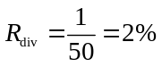
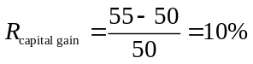
The realized return on the equity investment is 12%. The dividend yield is 10%.
10-5. Repeat Problem 4 assuming that the stock fell $5 to $45 instead.
a. Is your capital gain different? Why or why not?
b. Is your dividend yield different? Why or why not?
Compute the capital gain and dividend yield under the assumption that the stock price has fallen to $45.
a. 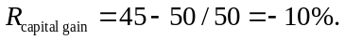Yes, the capital gain is different, because the difference between the current price and the purchase price is different than in Problem 1.
b. The dividend yield does not change, because the dividend is the same as in Problem 1.
The capital gain changes with the new lower price; the dividend yield does not change.
10-6. Using the data in the following table, calculate the return for investing in Boeing stock (BA) from January 2, 2008, to January 2, 2009, and also from January 3, 2011, to January 3, 2012, assuming all dividends are reinvested in the stock immediately.

Historical Stock and Dividend Data for Boeing
Date | Price | Dividend | Date | Price | Dividend
1/2/2008 | 86.62 |  | 1/3/2011 | 66.40
2/6/2008 | 79.91 | 0.40 | 2/9/2011 | 72.63 | 0.42
5/7/2008 | 84.55 | 0.40 | 5/11/2011 | 79.08 | 0.42
8/6/2008 | 65.40 | 0.40 | 8/10/2011 | 57.41 | 0.42
11/5/2008 | 49.55 | 0.40 | 11/8/2011 | 66.65 | 0.42
1/2/2009 | 45.25 |  | 1/3/2012 | 74.22

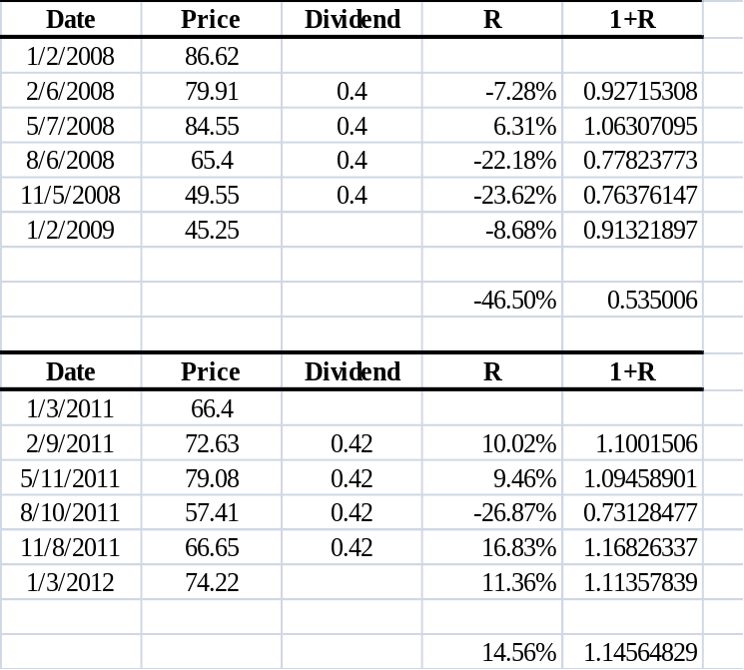
10-7. The last four years of returns for a stock are as follows:
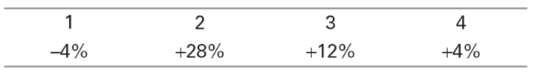
a. What is the average annual return?
b. What is the variance of the stock’s returns?
c. What is the standard deviation of the stock’s returns?
Given the data presented, make the calculations requested in the question.
a. 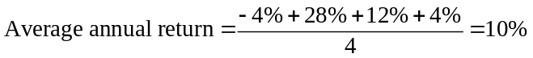
b. 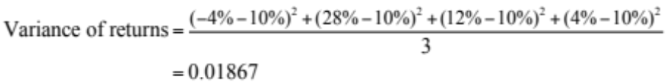
c.
The average annual return is 10%. The variance of return is 0.01867. The standard deviation of returns is 13.66%.
10-8. Assume that historical returns and future returns are independently and identically distributed, and drawn from the same distribution.
a. Calculate the 95% confidence intervals for the expected annual return of four different investments included in Tables 10.3 and 10.4 (the dates are inclusive, so the time period spans 86 years).
b. Assume that the values in Tables 10.3 and 10.4 are the true expected return and volatility (i.e., estimated without error) and that these returns are normally distributed. For each investment, calculate the probability that an investor will not lose more than 5% in the next year. (Hint: you can use the function normdist (x,mean,volatility,1) in Excel to compute the probability that a normally distributed variable with a given mean and volatility will fall below x.)
c. Do all the probabilities you calculated in part (b) make sense? If so, explain. If not, can you identify the reason?

Investment | Return Volatility (Standard Deviation) | Average Annual Return | Standard Error | Lower Bound Confidence Interval | Upper Bound Confidence Interval |  | Part b answer
Small stocks | 39.20% | 18.70% | 4.23% | 10.24% | 27.16% | 27.27% | 72.73%
S&P 500 | 20.30% | 11.70% | 2.19% | 7.32% | 16.08% | 20.54% | 79.46%
Corporate bonds | 7.00% | 6.60% | 0.75% | 5.10% | 8.10% | 4.87% | 95.13%
Treasury bills | 3.10% | 3.90% | 0.33% | 2.93% | 4.27% | 0.20% | 99.80%

c. No. You cannot lose money on Treasury Bills. The problem is that the returns to Treasuries are not normally distributed.
10-9. Using the data in Table 10.2,
a. What was the average annual return of Microsoft stock from 2002–2011?
b. What was the annual volatility for Microsoft stock from 2002–2011?
a. Average annual return
= (–22% + 6.8% + 8.9% – 0.9% + 15.8% + 20.8% –44.4% + 60.5% – 6.5% –4.5%) = 3.45%
b. Annual volatility of returns =
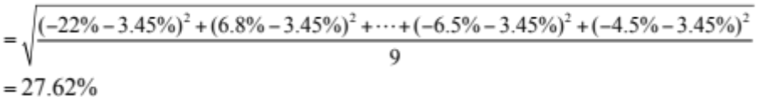
10-10. Using the data in Table 10.2,
a. What was the average dividend yield for the SP500 from 2002–2011?
b. What was the volatility of the dividend yield?
c. What was the average annual return of the SP500 from 2002–2011 excluding dividends (i.e., from capital gains only)?
d. What was the volatility of the S&P 500 returns from capital gains?
e. Were dividends or capital gains a more important component of the S&P 500’s average returns during this period? Which were the more important source of volatility?
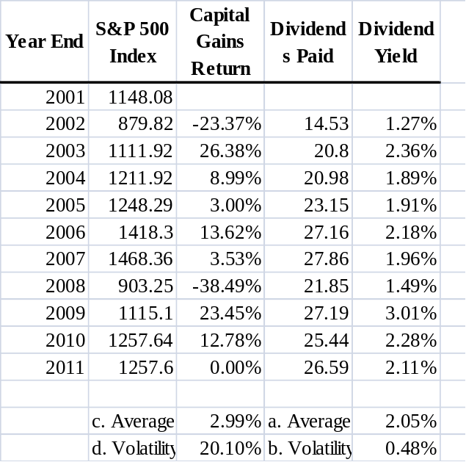
e. Capital gains were more important for returns and volatility.
10-11. Consider an investment with the following returns over four years:
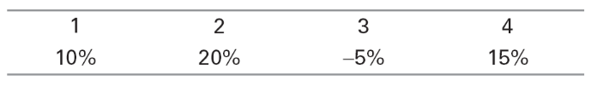
a. What is the compound annual growth rate (CAGR) for this investment over the four years?
b. What is the average annual return of the investment over the four years?
c. Which is a better measure of the investment’s past performance?
d. If the investment’s returns are independent and identically distributed, which is a better measure of the investment’s expected return next year?
a.
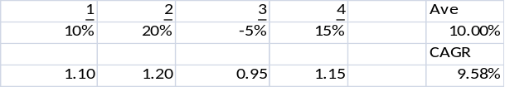
b. See table above
c. CAGR
d. Arithmetic average
10-12. Download the spreadsheet from MyFinanceLab that contains historical monthly prices and dividends (paid at the end of the month) for Ford Motor Company stock (Ticker: F) from August 1994 to August 1998. Calculate the realized return over this period, expressing your answer in percent per month (i.e., what monthly return would have led to the same cumulative performance as an investment in Ford stock over this period).

Ford Motor Co (F)

Date | Stock Price | Dividend | Return | 1+R_{t}
Aug-94 | $29.25 | $0.00
Sep-94 | $27.75 | $0.00 | -5.13% | 0.949
Oct-94 | $29.50 | $0.26 | 7.24% | 1.072
Nov-94 | $27.13 | $0.00 | -8.05% | 0.919
Dec-94 | $27.88 | $0.00 | 2.76% | 1.028
Jan-95 | $25.25 | $0.26 | -8.48% | 0.915
Feb-95 | $26.13 | $0.00 | 3.47% | 1.035
Mar-95 | $26.88 | $0.00 | 2.87% | 1.029
Apr-95 | $27.13 | $0.31 | 2.08% | 1.021
May-95 | $29.25 | $0.00 | 7.83% | 1.078
Jun-95 | $29.75 | $0.00 | 1.71% | 1.017
Jul-95 | $29.00 | $0.31 | -1.48% | 0.985
Aug-95 | $30.75 | $0.00 | 6.03% | 1.060
Sep-95 | $31.13 | $0.00 | 1.22% | 1.012
Oct-95 | $28.75 | $0.35 | -6.51% | 0.935
Nov-95 | $28.25 | $0.00 | -1.74% | 0.983
Dec-95 | $28.88 | $0.00 | 2.21% | 1.022
Jan-96 | $29.50 | $0.35 | 3.38% | 1.034
Feb-96 | $31.25 | $0.00 | 5.93% | 1.059
Mar-96 | $34.38 | $0.00 | 10.00% | 1.100
Apr-96 | $35.88 | $0.35 | 5.38% | 1.054
May-96 | $36.50 | $0.00 | 1.74% | 1.017
Jun-96 | $32.38 | $0.00 | -11.30% | 0.887
Jul-96 | $32.38 | $0.39 | 1.19% | 1.012
Aug-96 | $33.50 | $0.00 | 3.47% | 1.035
Sep-96 | $31.25 | $0.00 | -6.72% | 0.933
Oct-96 | $31.25 | $0.39 | 1.23% | 1.012
Nov-96 | $32.75 | $0.00 | 4.80% | 1.048
Dec-96 | $32.25 | $0.00 | -1.53% | 0.985
Jan-97 | $32.13 | $0.39 | 0.81% | 1.008
Feb-97 | $32.88 | $0.00 | 2.33% | 1.023
Mar-97 | $31.38 | $0.00 | -4.56% | 0.954
Apr-97 | $34.75 | $0.42 | 12.10% | 1.121
May-97 | $37.50 | $0.00 | 7.91% | 1.079
Jun-97 | $38.00 | $0.00 | 1.33% | 1.013
Jul-97 | $40.88 | $0.42 | 8.67% | 1.087
Aug-97 | $43.00 | $0.00 | 5.20% | 1.052
Sep-97 | $45.13 | $0.00 | 4.94% | 1.049
Oct-97 | $43.69 | $0.42 | -2.25% | 0.977
Nov-97 | $43.00 | $0.00 | -1.57% | 0.984
Dec-97 | $48.56 | $0.00 | 12.94% | 1.129
Jan-98 | $51.00 | $0.42 | 5.88% | 1.059
Feb-98 | $56.56 | $0.00 | 10.91% | 1.109
Mar-98 | $64.81 | $0.00 | 14.59% | 1.146
Apr-98 | $45.81 | $23.68 | 7.22% | 1.072
May-98 | $51.88 | $0.00 | 13.23% | 1.132
Jun-98 | $59.00 | $0.00 | 13.73% | 1.137
Jul-98 | $57.00 | $0.42 | -2.68% | 0.973
Aug-98 | $44.63 | $0.00 | -21.71% | 0.783

Total Return (product of 1+R’s) |  |  | 1.7102
Equivalent Monthly return = (TotalReturn)^(1/48)-1 |  |  | 2.10%

10-13. Using the same data as in Problem 12, compute the
a. Average monthly return over this period.
b. Monthly volatility (or standard deviation) over this period.

a. Average Return over this period: 2.35%
b. Standard Deviation over this period: 7.04%
10-14. Explain the difference between the average return you calculated in Problem 13(a) and the realized return you calculated in Problem 12. Are both numbers useful? If so, explain why.
Both numbers are useful. The realized return (in problem 12) tells you what you actually made if you hold the stock over this period. The average return (problem 13(a)) over the period can be used as an estimate of the monthly expected return. If you use this estimate, then this is what you expect to make on the stock in the next month.
10-15. Compute the 95% confidence interval of the estimate of the average monthly return you calculated in Problem 13(a).
Month | Stock Price | Dividend |  | Return
Aug-98 | 44.625 |  |  | -0.21711
Jul-98 | 57.000 | 0.420 |  | -0.02678
Jun-98 | 59.000 |  |  | 0.13735
May-98 | 51.875 |  |  | 0.13233
Apr-98 | 45.813 | 23.680 |  | 0.07221
Mar-98 | 64.813 |  |  | 0.14586
Feb-98 | 56.563 |  |  | 0.10907
Jan-98 | 51.000 | 0.420 |  | 0.05884
Dec-97 | 48.563 |  |  | 0.12936
Nov-97 | 43.000 |  |  | -0.01574
Oct-97 | 43.688 | 0.420 |  | -0.02255
Sep-97 | 45.125 |  |  | 0.04942
Aug-97 | 43.000 |  |  | 0.05199
Jul-97 | 40.875 | 0.420 |  | 0.08671
Jun-97 | 38.000 |  |  | 0.01333
May-97 | 37.500 |  |  | 0.07914
Apr-97 | 34.750 | 0.420 |  | 0.12096
Mar-97 | 31.375 |  |  | -0.04563
Feb-97 | 32.875 |  |  | 0.02335
Jan-97 | 32.125 | 0.385 |  | 0.00806
Dec-96 | 32.250 |  |  | -0.01527
Nov-96 | 32.750 |  |  | 0.04800
Oct-96 | 31.250 | 0.385 |  | 0.01232
Sep-96 | 31.250 |  |  | -0.06716
Aug-96 | 33.500 |  |  | 0.03475
Jul-96 | 32.375 | 0.385 |  | 0.01189
Jun-96 | 32.375 |  |  | -0.11301
May-96 | 36.500 |  |  | 0.01742
Apr-96 | 35.875 | 0.350 |  | 0.05382
Mar-96 | 34.375 |  |  | 0.10000
Feb-96 | 31.250 |  |  | 0.05932
Jan-96 | 29.500 | 0.350 |  | 0.03377
Dec-95 | 28.875 |  |  | 0.02212
Nov-95 | 28.250 |  |  | -0.01739
Oct-95 | 28.750 | 0.350 |  | -0.06506
Sep-95 | 31.125 |  |  | 0.01220
Aug-95 | 30.750 |  |  | 0.06034
Jul-95 | 29.000 | 0.310 |  | -0.01479
Jun-95 | 29.750 |  |  | 0.01709
May-95 | 29.250 |  |  | 0.07834
Apr-95 | 27.125 | 0.310 |  | 0.02084
Mar-95 | 26.875 |  |  | 0.02871
Feb-95 | 26.125 |  |  | 0.03465
Jan-95 | 25.250 | 0.260 |  | -0.08484
Dec-94 | 27.875 |  |  | 0.02765
Nov-94 | 27.125 |  |  | -0.08051
Oct-94 | 29.500 | 0.260 |  | 0.07243
Sep-94 | 27.750 |  |  | -0.05128
Aug-94 | 29.250
Average Monthly Return |  |  |  |  | 2.35%
Std Dev of Monthly Return |  |  |  |  | 7.04%
Std Error of Estimate = (Std Dev)/sqrt(36) = |  |  |  |  | 1.02%
95% Confidence Interval of average monthly return |  |  |  |  | 0.31% | 4.38%

10-16. How does the relationship between the average return and the historical volatility of individual stocks differ from the relationship between the average return and the historical volatility of large, well-diversified portfolios?
For large portfolios there is a relationship between returns and volatility—portfolios with higher returns have higher volatilities. For stocks, no clear relation exists.
10-17. Download the spreadsheet from MyFinanceLab containing the data for Figure 10.1.
a. Compute the average return for each of the assets from 1929 to 1940 (The Great Depression).
b. Compute the variance and standard deviation for each of the assets from 1929 to 1940.
c. Which asset was riskiest during the Great Depression? How does that fit with your intuition?
a/b.
 | S&P 500 | Small Stocks | Corp Bonds | World Portfolio | Treasury Bills | CPI
Average | 4.44% | 17.69% | 5.22% | 1.95% | 0.82% | -1.56%
Variance: | 0.13267 | 0.45790 | 0.00093 | 0.03865 | 0.00002 | 0.00067
Standard deviation: | 36.42% | 67.67% | 3.05% | 19.66% | 0.40% | 2.59%

Evaluate:
c. The riskiest assets were the small stocks. Intuition tells us that this asset class would be the riskiest.
10-18. Using the data from Problem 17, repeat your analysis over the 1990s.
a. Which asset was riskiest?
b. Compare the standard deviations of the assets in the 1990s to their standard deviations in the Great Depression. Which had the greatest difference between the two periods?
c. If you only had information about the 1990s, what would you conclude about the relative risk of investing in small stocks?
a. Using Excel:
 | S&P 500 | Small Stocks | Corp Bonds | World Portfolio | Treasury Bills | CPI
Average | 18.49% | 8.92% | 9.95% | 16.13% | 5.21% | 3.09%
Variance: | 0.02279 | 0.03436 | 0.00294 | 0.02180 | 0.00002 | 0.00005
Standard deviation: | 15.10% | 18.54% | 5.42% | 14.76% | 0.43% | 0.72%

The riskiest asset class was small stocks.
b. The greatest absolute difference in standard deviation is in the small stocks asset class, which saw standard deviation fall 49.1%. But in relative terms, the riskiness of corporate bonds rose 77.7% (relative to 1940), while the riskiness of small stocks fell only 72.6% (relative to 1940 levels). Inflation is now much less risky as well, falling in relative riskiness by 72.2%.
c. If you were only looking at the 1990s, you would conclude that small stocks are relatively less risky than they actually are.
The results that one can derive from analyzing data from a particular time period can change depending on the time period analyzed. These differences can be large if the time periods being analyzed are short.
10-19. What if the last two decades had been “normal”? Download the spreadsheet from MyFinanceLab containing the data for Figure 10.1.
a. Calculate the arithmetic average return on the S&P 500 from 1926 to 1989.
b. Assuming that the S&P 500 had simply continued to earn the average return from (a), calculate the amount that $100 invested at the end of 1925 would have grown to by the end of 2011.
c. Do the same for small stocks.
a. The arithmetic average return of the S&P 500 for 1926–1989 is 11.758%.
b. Using 11.758% as the annual return during the period 1990–2011, $100 invested in the S&P 500 in 1926 would have grown to $558,063 by 2011.
c. The arithmetic average return for small stocks for 1926–1989 is 18.057%. Using 18.057% as the annual return during the period 1990–2011, $100 invested in small stocks in 1926 would have grown to $11,012,413 by 2011.
10-20. Consider two local banks. Bank A has 100 loans outstanding, each for $1 million, that it expects will be repaid today. Each loan has a 5% probability of default, in which case the bank is not repaid anything. The chance of default is independent across all the loans. Bank B has only one loan of $100 million outstanding, which it also expects will be repaid today. It also has a 5% probability of not being repaid. Explain the difference between the type of risk each bank faces. Which bank faces less risk? Why?
The expected payoffs are the same, but bank A is less risky. (See solution to Problem 10–21 for full explanation of the banks’ relative risk levels.)
10-21. Using the data in Problem 20, calculate
a. The expected overall payoff of each bank.
b. The standard deviation of the overall payoff of each bank.
a. Expected payoff is the same for both banks
b. Bank B
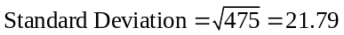
Bank A
Now the bank has 100 loans that are all independent of each other so the standard deviation of the average loan is
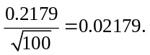
But the bank has 100 such loans so the standard deviation of the portfolio is
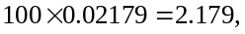
which is much lower than Bank B.
10-22. Consider the following two, completely separate, economies. The expected return and volatility of all stocks in both economies is the same. In the first economy, all stocks move together—in good times all prices rise together and in bad times they all fall together. In the second economy, stock returns are independent—one stock increasing in price has no effect on the prices of other stocks. Assuming you are risk-averse and you could choose one of the two economies in which to invest, which one would you choose? Explain.
A risk-averse investor would choose the economy in which stock returns are independent because this risk can be diversified away in a large portfolio.
10-23. Consider an economy with two types of firms, S and I. S firms all move together. I firms move independently. For both types of firms, there is a 60% probability that the firms will have a 15% return and a 40% probability that the firms will have a −10% return. What is the volatility (standard deviation) of a portfolio that consists of an equal investment in 20 firms of (a) type S, and (b) type I?
a. 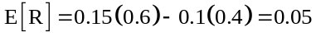
Because all S firms in the portfolio move together there is no diversification benefit. So the standard deviation of the portfolio is the same as the standard deviation of the stocks—12.25%.
b. 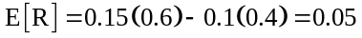
Type I stocks move independently. Hence the standard deviation of the portfolio is
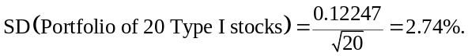
10-24. Using the data in Problem 23, plot the volatility as a function of the number of firms in the two portfolios.
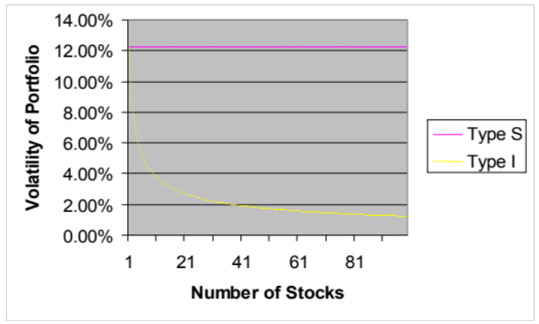
Expected return of a stock | 0.05
Standard Deviation of a stock | 0.122474

Number of Stocks | Type S | Type I | Number of Stocks | Type S | Type I | Number of Stocks | Type S | Type I | Number of Stocks | Type S | Type I
1 | 12.25% | 12.25% | 29 | 12.25% | 2.27% | 57 | 12.25% | 1.62% | 85 | 12.25% | 1.33%
2 | 12.25% | 8.66% | 30 | 12.25% | 2.24% | 58 | 12.25% | 1.61% | 86 | 12.25% | 1.32%
3 | 12.25% | 7.07% | 31 | 12.25% | 2.20% | 59 | 12.25% | 1.59% | 87 | 12.25% | 1.31%
4 | 12.25% | 6.12% | 32 | 12.25% | 2.17% | 60 | 12.25% | 1.58% | 88 | 12.25% | 1.31%
5 | 12.25% | 5.48% | 33 | 12.25% | 2.13% | 61 | 12.25% | 1.57% | 89 | 12.25% | 1.30%
6 | 12.25% | 5.00% | 34 | 12.25% | 2.10% | 62 | 12.25% | 1.56% | 90 | 12.25% | 1.29%
7 | 12.25% | 4.63% | 35 | 12.25% | 2.07% | 63 | 12.25% | 1.54% | 91 | 12.25% | 1.28%
8 | 12.25% | 4.33% | 36 | 12.25% | 2.04% | 64 | 12.25% | 1.53% | 92 | 12.25% | 1.28%
9 | 12.25% | 4.08% | 37 | 12.25% | 2.01% | 65 | 12.25% | 1.52% | 93 | 12.25% | 1.27%
10 | 12.25% | 3.87% | 38 | 12.25% | 1.99% | 66 | 12.25% | 1.51% | 94 | 12.25% | 1.26%
11 | 12.25% | 3.69% | 39 | 12.25% | 1.96% | 67 | 12.25% | 1.50% | 95 | 12.25% | 1.26%
12 | 12.25% | 3.54% | 40 | 12.25% | 1.94% | 68 | 12.25% | 1.49% | 96 | 12.25% | 1.25%
13 | 12.25% | 3.40% | 41 | 12.25% | 1.91% | 69 | 12.25% | 1.47% | 97 | 12.25% | 1.24%
14 | 12.25% | 3.27% | 42 | 12.25% | 1.89% | 70 | 12.25% | 1.46% | 98 | 12.25% | 1.24%
15 | 12.25% | 3.16% | 43 | 12.25% | 1.87% | 71 | 12.25% | 1.45% | 99 | 12.25% | 1.23%
16 | 12.25% | 3.06% | 44 | 12.25% | 1.85% | 72 | 12.25% | 1.44%
17 | 12.25% | 2.97% | 45 | 12.25% | 1.83% | 73 | 12.25% | 1.43%
18 | 12.25% | 2.89% | 46 | 12.25% | 1.81% | 74 | 12.25% | 1.42%
19 | 12.25% | 2.81% | 47 | 12.25% | 1.79% | 75 | 12.25% | 1.41%
20 | 12.25% | 2.74% | 48 | 12.25% | 1.77% | 76 | 12.25% | 1.40%
21 | 12.25% | 2.67% | 49 | 12.25% | 1.75% | 77 | 12.25% | 1.40%
22 | 12.25% | 2.61% | 50 | 12.25% | 1.73% | 78 | 12.25% | 1.39%
23 | 12.25% | 2.55% | 51 | 12.25% | 1.71% | 79 | 12.25% | 1.38%
24 | 12.25% | 2.50% | 52 | 12.25% | 1.70% | 80 | 12.25% | 1.37%
25 | 12.25% | 2.45% | 53 | 12.25% | 1.68% | 81 | 12.25% | 1.36%
26 | 12.25% | 2.40% | 54 | 12.25% | 1.67% | 82 | 12.25% | 1.35%
27 | 12.25% | 2.36% | 55 | 12.25% | 1.65% | 83 | 12.25% | 1.34%
28 | 12.25% | 2.31% | 56 | 12.25% | 1.64% | 84 | 12.25% | 1.34%
10-25. Explain why the risk premium of a stock does not depend on its diversifiable risk.
Investors can costlessly remove diversifiable risk from their portfolio by diversifying. They, therefore, do not demand a risk premium for it.
10-26. Identify each of the following risks as most likely to be systematic risk or diversifiable risk:
a. The risk that your main production plant is shut down due to a tornado.
b. The risk that the economy slows, decreasing demand for your firm’s products.
c. The risk that your best employees will be hired away.
d. The risk that the new product you expect your R&D division to produce will not materialize.
a. diversifiable risk
b. systematic risk
c. diversifiable risk
d. diversifiable risk
10-27. Suppose the risk-free interest rate is 5%, and the stock market will return either 40% or −20% each year, with each outcome equally likely. Compare the following two investment strategies: (1) invest for one year in the risk-free investment, and one year in the market, or (2) invest for both years in the market.
a. Which strategy has the highest expected final payoff?
b. Which strategy has the highest standard deviation for the final payoff?
c. Does holding stocks for a longer period decrease your risk?
R(i) : (1.05)(1.40) – 1 = 47% or (1.05)(0.80) – 1 = –16%
R(ii) : 1.4² – 1 = 96%, 1.4 × 0.8 – 1 = 12%, 0.8 × 1.4 – 1=12%, .8 × .8 – 1 = –36%
a. ER(i) = (47% – 16%)/2 = 15.5%
ER(ii) = (96% + 12% + 12% – 36%)/4 = 21%
b. Vol(i) =sqrt(1/2 (47% – 15.5%)² + 1/2(–16% – 15.5%)²) = 31.5%
Vol(ii)=sqrt(1/4 (96%-21%)² + ½(12% – 21%)² + 1/4(–36% – 21%)²) = 47.5%
c. No
10-28. Download the spreadsheet from MyFinanceLab containing the realized return of the S&P 500 from 1929–2008. Starting in 1929, divide the sample into four periods of 20 years each. For each 20-year period, calculate the final amount an investor would have earned given a $1000 initial investment. Also express your answer as an annualized return. If risk were eliminated by holding stocks for 20 years, what would you expect to find? What can you conclude about long-run diversification?

Amount after 1929–1948 Period | $1,741.26 | 2.81%
Amount after 1949–1968 Period | $15,847.97 | 14.82%
Amount after 1969–1988 Period | $6,094.61 | 9.46%
Amount after 1989–2008 Period | $5,043.04 | 8.43%

If risk were eliminated by holding stocks for 20 years, you would expect to find similar returns for all four periods, which you do not.
10-29. What is an efficient portfolio?
An efficient portfolio is any portfolio that only contains systemic risk; it contains no diversifiable risk.
10-30. What does the beta of a stock measure?
Beta measures the amount of systemic risk in a stock
10-31. You turn on the news and find out the stock market has gone up 10%. Based on the data in Table 10.6, by how much do you expect each of the following stocks to have gone up or down: (1) Starbucks, (2) Tiffany & Co., (3) Hershey, and (4) McDonald’s.
Beta*10%
Starbucks 12%
Tiffany & Co. 18%
Hershey 2.8%
McDonald’s 4.7%
10-32. Based on the data in Table 10.6, estimate which of the following investments you expect to lose the most in the event of a severe market downturn: (1) A $1000 investment in eBay, (2) a $5000 investment in Abbott Laboratories, or (3) a $2500 investment in Walt Disney.
For each 10% market decline,
eBay down 10%*1.48 = 14.8%,
14.8% × 1000 = $148 loss;
Abbott down 10%*.31 = 3.1%,
3.1% × 5000 = $155 loss;
Disney down 10%*1.21 = 12.1%,
12.1% × 2500 = $302.50 loss;
Disney investment will lose most.
10-33. Suppose the market portfolio is equally likely to increase by 30% or decrease by 10%.
a. Calculate the beta of a firm that goes up on average by 43% when the market goes up and goes down by 17% when the market goes down.
b. Calculate the beta of a firm that goes up on average by 18% when the market goes down and goes down by 22% when the market goes up.
c. Calculate the beta of a firm that is expected to go up by 4% independently of the market.
a. 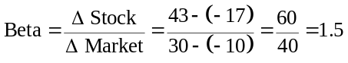
b. 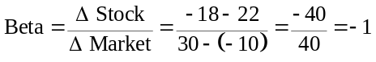
c. A firm that moves independently has no systemic risk, so beta = 0
10-34. Suppose the risk-free interest rate is 4%.
a. i. Use the beta you calculated for the stock in Problem 33(a) to estimate its expected return.
ii. How does this compare with the stock’s actual expected return?
b. i. Use the beta you calculated for the stock in Problem 33(b) to estimate its expected return.
ii. How does this compare with the stock’s actual expected return?
a. E[R_{M}] = ½ (30%) + ½ (–10%) = 10%
i.. E[R] = 4% + 1.5 (10% – 4%) = 13%
ii. Actual Expected return =
(43% – 17%) / 2 = 13%
b. i. E[R] = 4% – 1(10% – 4%) = –2%
ii. Actual l expected Return =
(–22% + 18%) / 2 = –2%
10-35. Suppose the market risk premium is 5% and the risk-free interest rate is 4%. Using the data in Table 10.6, calculate the expected return of investing in
a. Starbucks’ stock.
b. Hershey’s stock.
c. Autodesk’s stock.
a. 4% + 1.20 × 5% = 10%
b. 4% + 0.28 × 5% = 5.4%
c. 4% + 2.14 × 5% = 14.7%
10-36. Given the results to Problem 35, why don’t all investors hold Autodesk’s stock rather than Hershey’s stock?
Hershey’s stock has less market risk, so investors don’t need as high an expected return to hold it. Hershey’s stock will perform much better in a market downturn.
10-37. Suppose the market risk premium is 6.5% and the risk-free interest rate is 5%. Calculate the cost of capital of investing in a project with a beta of 1.2.
10-38. State whether each of the following is inconsistent with an efficient capital market, the CAPM, or both:
a. A security with only diversifiable risk has an expected return that exceeds the risk-free interest rate.
b. A security with a beta of 1 had a return last year of 15% when the market had a return of 9%.
c. Small stocks with a beta of 1.5 tend to have higher returns on average than large stocks with a beta of 1.5.
a. This statement is inconsistent with both.
b. This statement is consistent with both.
c. This statement is inconsistent with the CAPM but not necessarily with efficient capital markets.

